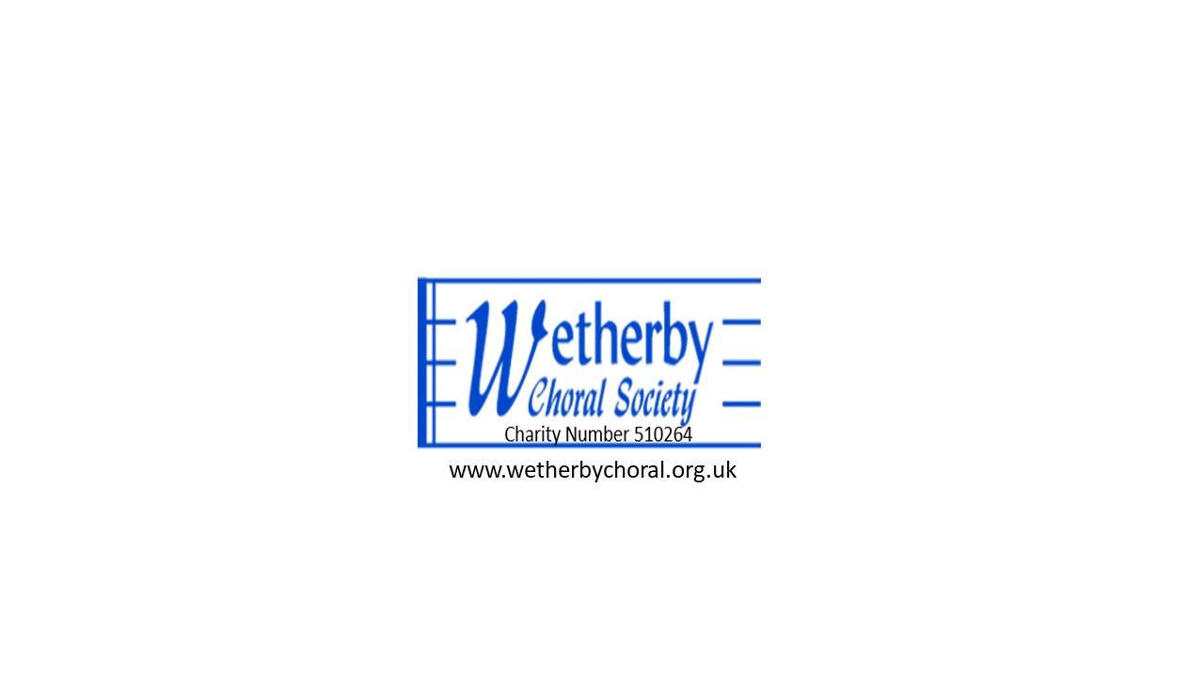
Notice and Agenda for the Annual General Meeting

Monday 21st October 2024 7.30pm St James’s Church Wetherby

1. Apologies

2. Minutes of the meeting held on 23 October 2023 – for approval (see attached)

3. Chairman’s Report

4. Treasurer’s Report and Financial Accounts (see attached)

5. Musical Director’s Report

6. Election of Committee members
(Nominations to be emailed to the Secretary by 14 October).

8 Any other business
(Please advise the Secretary by email in advance if you wish to raise anything)

27 September 2024

Malcolm Smith
Secretary, Wetherby Choral Society
mdsmith55@gmail.com
Tel: 07926 194006

